**Functional Document**

|  |  |
| --- | --- |
| **Application** | NGERP - Centra |
| **Service Bundle** | Sales Management |
| **Service Request** | Payment Netoff |

**Description :**

Payment netoff is used to make payment to the AR invoice in Region. some customers directly make payment to abbott, so abbott make a centrilized payment netoff which will be synched to region. User can make payment by choosing the netoff of receipt in the payment screen.

**Workflow Process :**

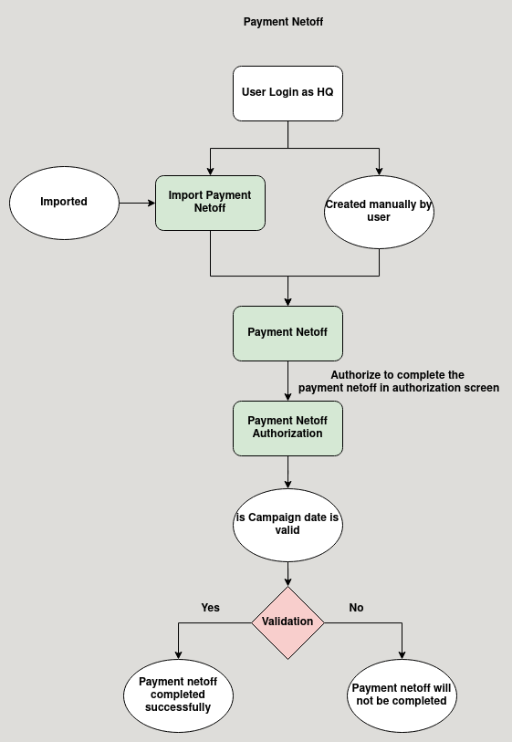

**Business Rules :**

* Payment netoff can be accessed only in HQ.
* Payment netoff can be created both manually and by importing in file loader.
* The length of pair number is 9, first character in pair number should be 3 followed by the date two digit followed by month two digits then a hypen followed by 3 digit number.
* payment netoff is completed can be only in batch complete payment netoff.
* payment netoff is matched with a payment in region by using the pair number.
* The document type for the payment netoff in payment screen is netoff receipt.
* After completing the payment the payment is loaded in payment allocation screen in region.